# COMPONENTS SPLITTED

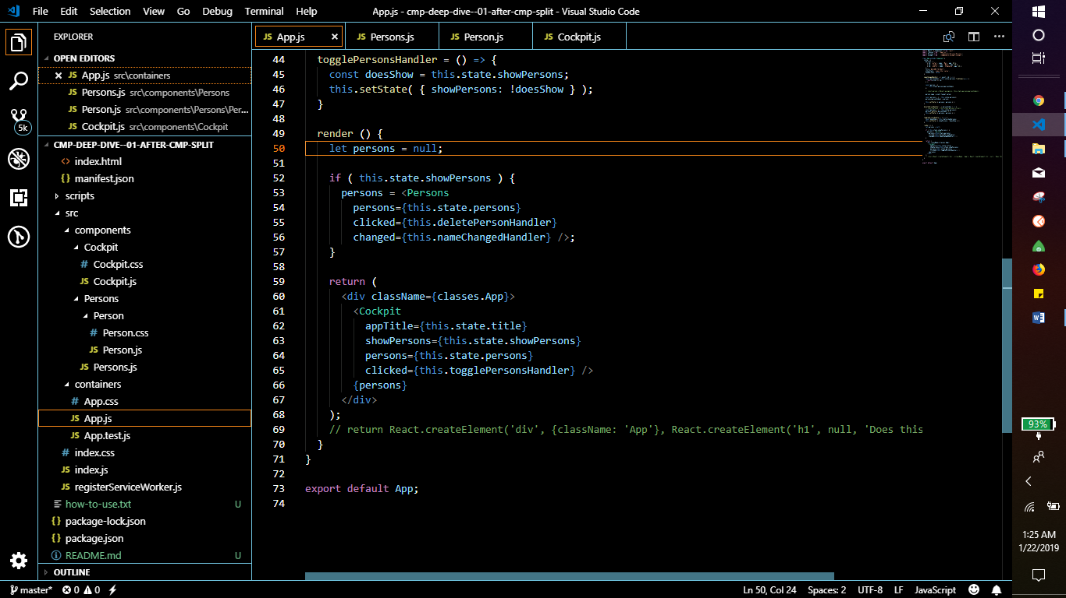

THIS IS APP.JS

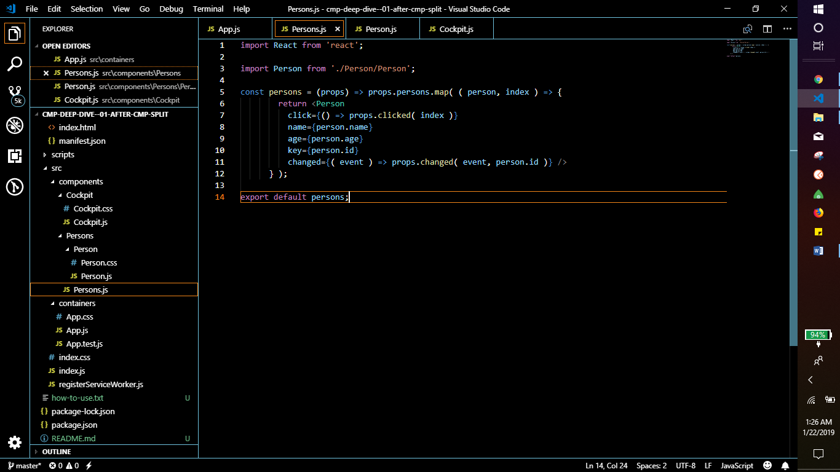

PERSONS.JS

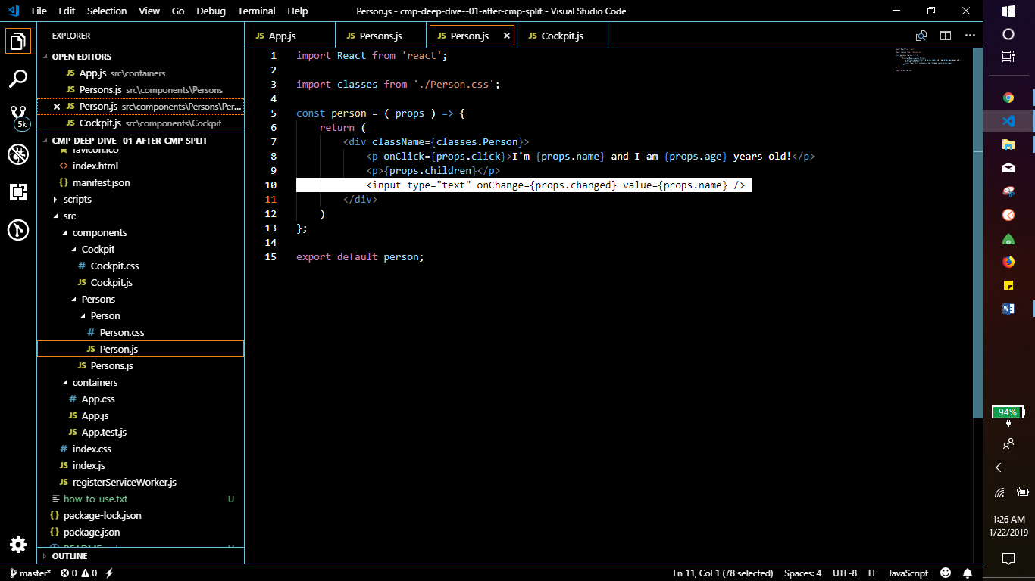

PERSON.JS

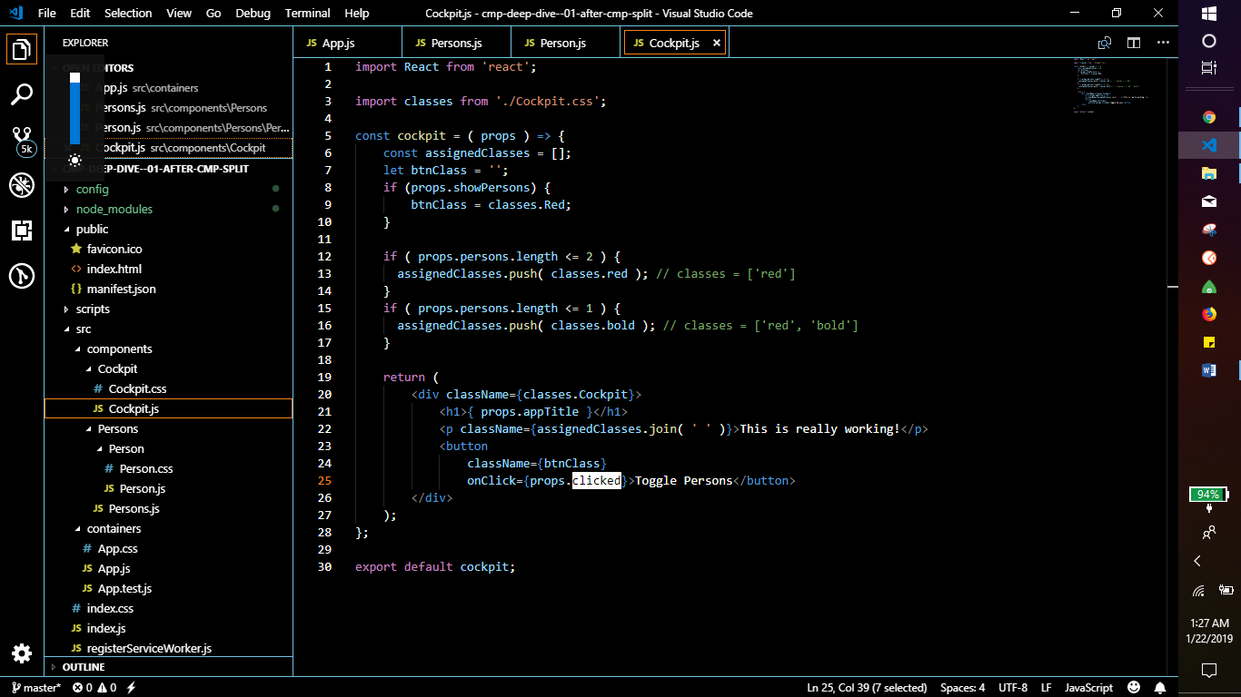

COCKPIT.JS

# COMPARING STATELESS AND STATEFUL COMPONENTS

**STATELESS** IS PRESENTATIONAL. PERSON AND COCKPIT

STATEFUL PASSES DATA TO STATELEESS PRESENTATIONAL COMPONENTS USING PROPS PROPS PASS FROM PARENT TO CHILD COMPONENTS

**STATEFUL** ARE CONTAINER APP.JS

STATEFUL COMPONENTS HAS ITS OWN DATA

STATE IS INTERNAL TO A COMPONENT, WHILE PROPS ARE PASSED TO A COMPONENT.

# CLASS-BASED VS FUNCTIONAL COMPONENTS

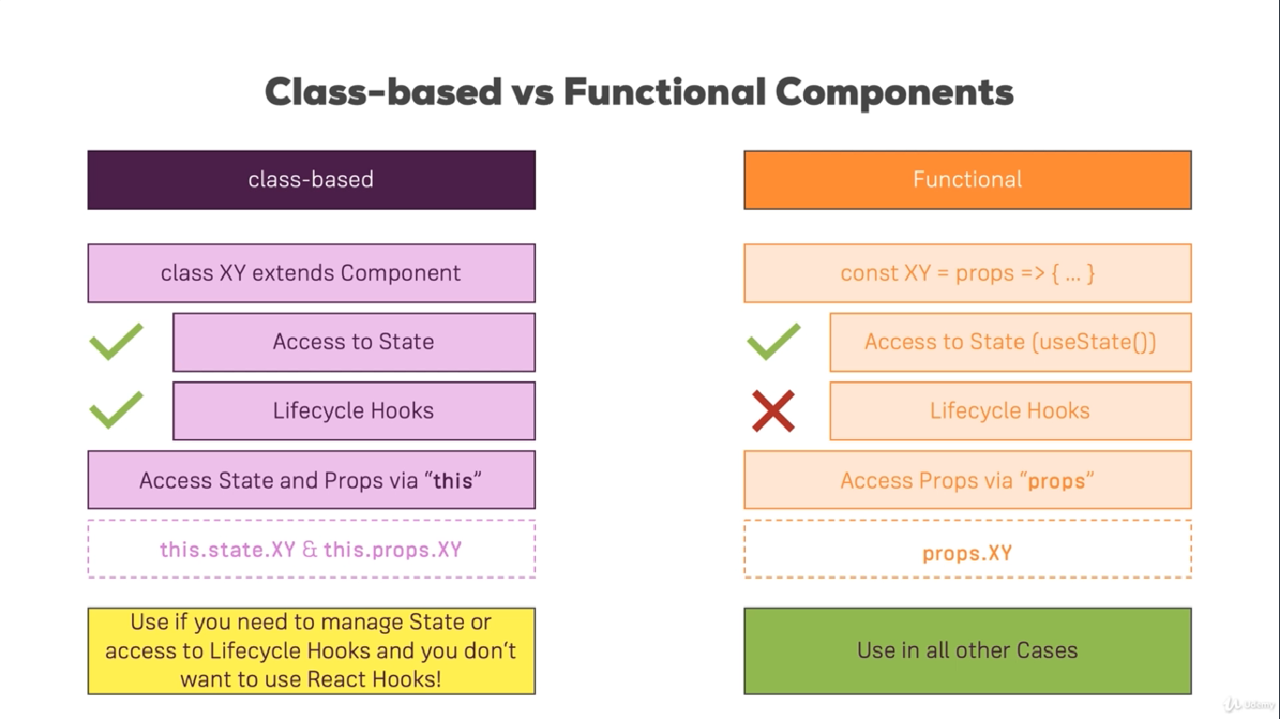

FUNCTIONAL BASED COMPONENTS APPROACH NEEDS USESTATE HOOK TO ACCESS STATE

# CLASS COMPONENT LIFECYCLE OVERVIEW

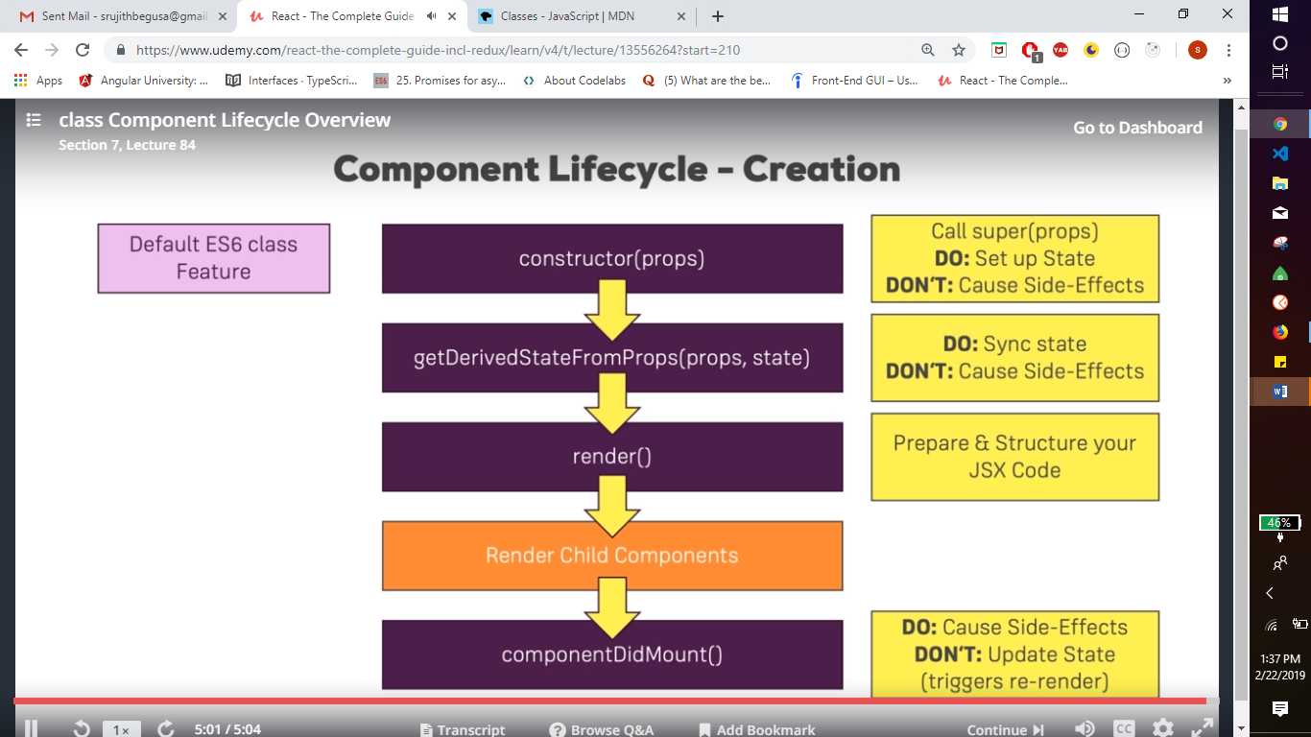

**GETDERIVEDSTATEFROMPROPS** EXISTS FOR ONLY ONE PURPOSE. IT ENABLES A COMPONENT TO UPDATE ITS INTERNAL STATE AS THE RESULT OF CHANGES IN PROPS.  WE CAN FACE SCENERIO WHERE PROPS CANT RENDER BEFOR PASSING TO CHILD COMPONENT SO WE UPDATE PROPS

# COMPONENT CREATION LIFECYCLE IN ACTION

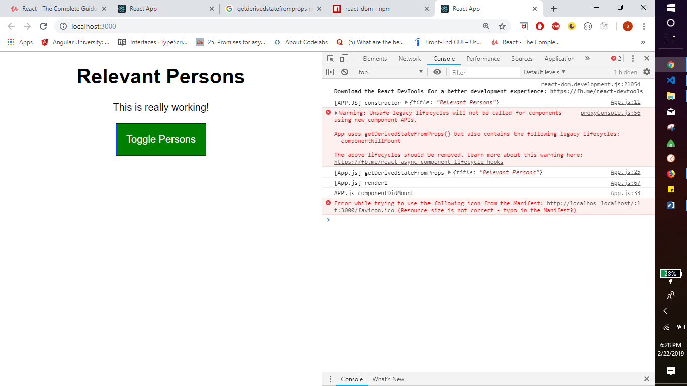

ORDER OF LIFE CYCLE

# COMPONENT UPDATE LIFECYCLE (FOR PROPS CHANGES)

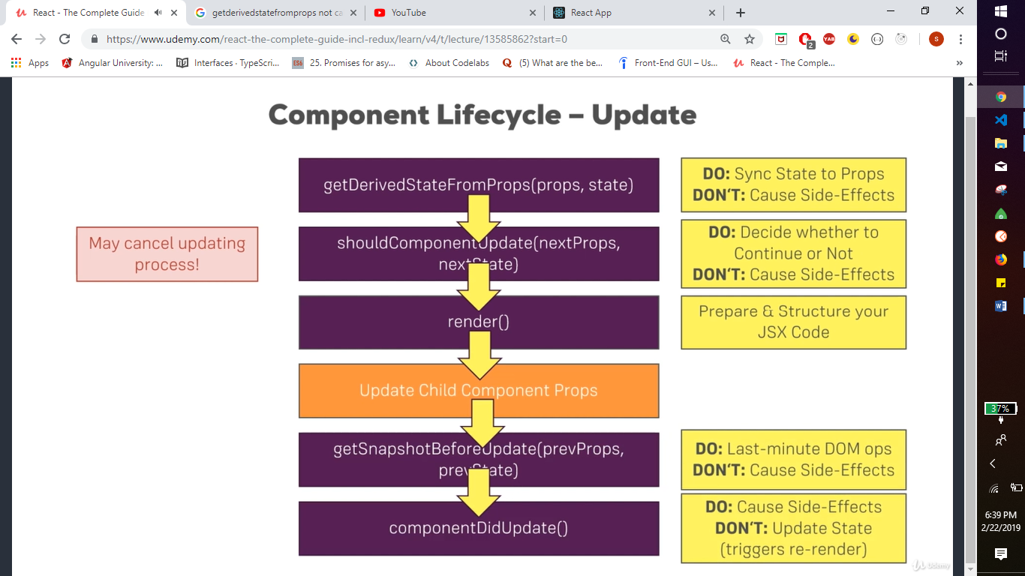

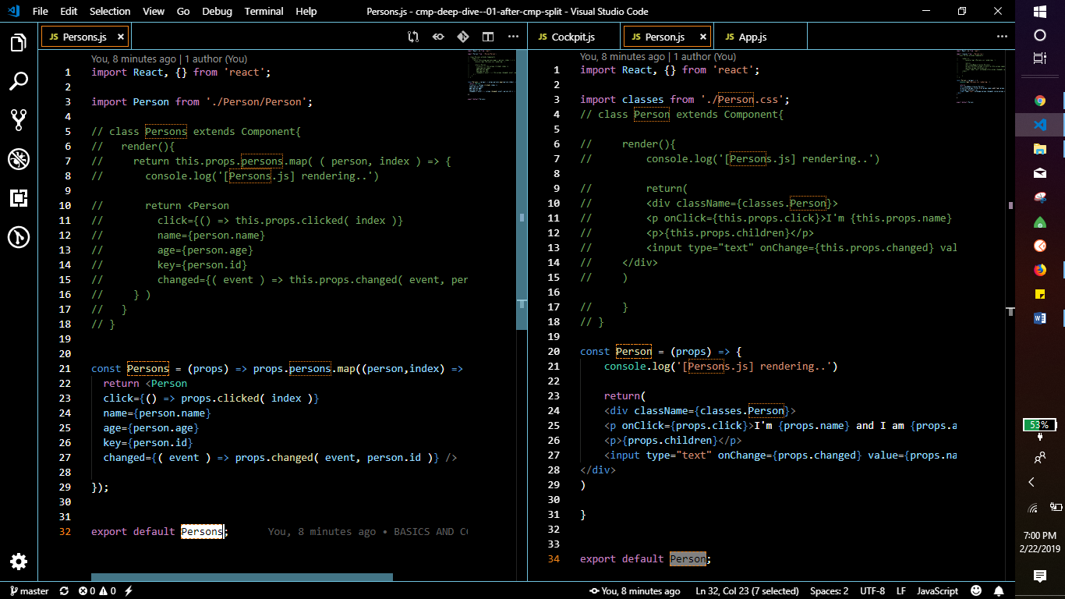

NOW THESE ARE NOT CLASS BASED COMPONENT

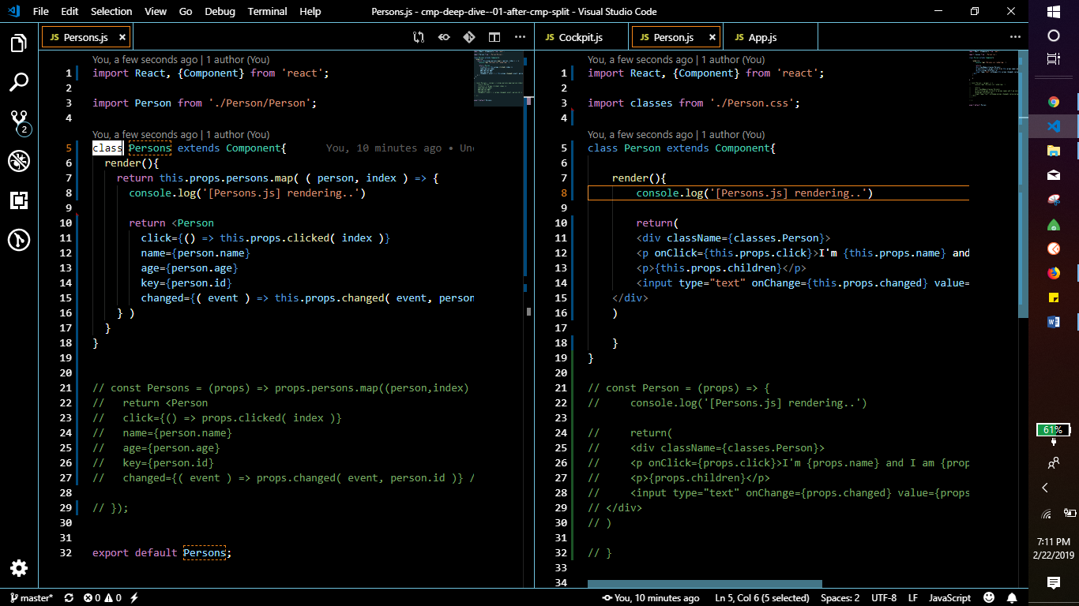

NOW WE ADD CLASS, SO WE CAN USE LIFECYCLE HOOKS

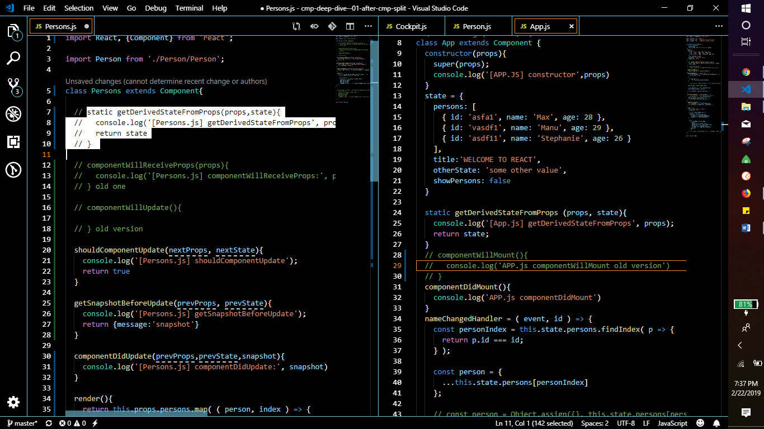

COMMENTED OUT ARE OLD LIFE CYCLES NO USE FOR LATEST PROJECT AND

GETDERIVEDSTATEFROMPROPS NEEDS INITIAL STATE DEFINED IN PERSONS COMPONENT AS IN APP.JS IF NOT IT ERRORS OUT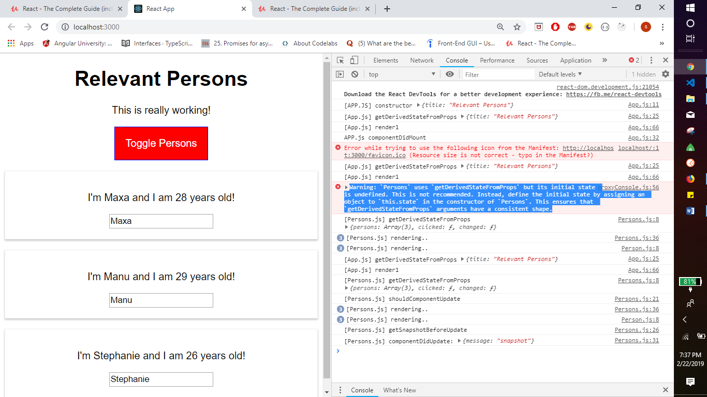

# COMPONENT UPDATE LIFECYCLE (FOR STATE CHANGES)

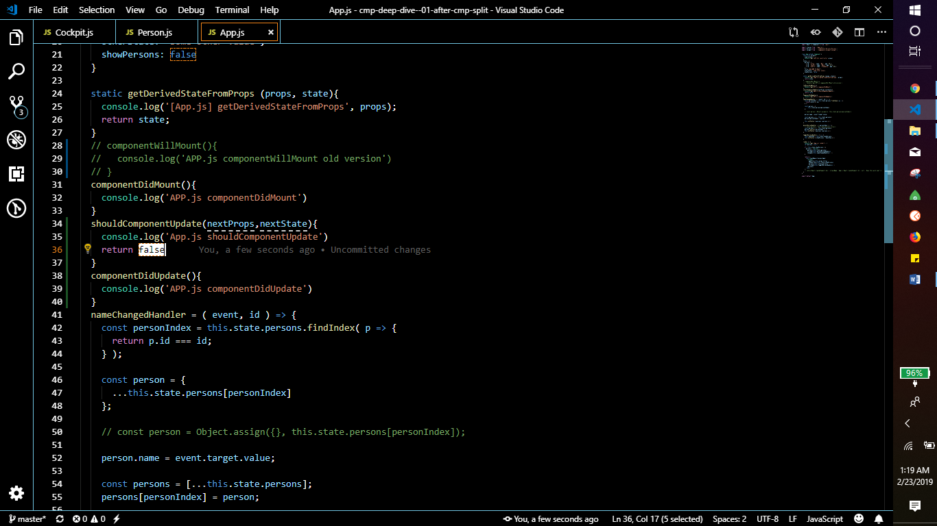

shouldComponentUpdate wont let us update state because it returns false so toggle button wont work

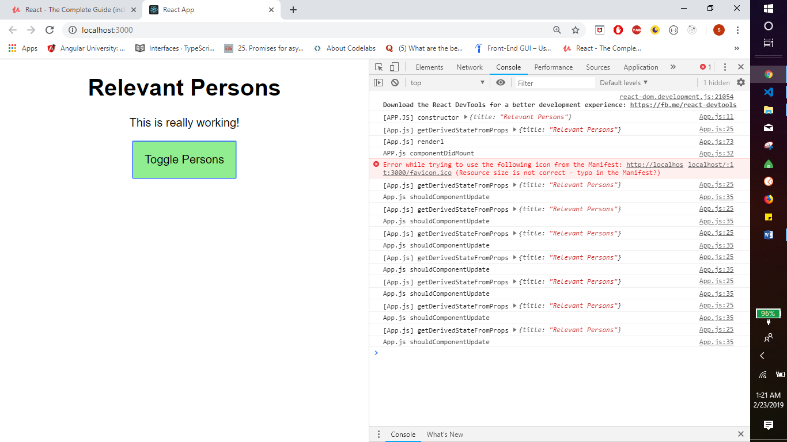

# USING USEEFFECT() IN FUNCTIONAL COMPONENTS